|  |  |
| --- | --- |
| Start Sheet for the  **Northampton & District Cycling Association**  **10 mile Time Trial** (TT Series Event 2 of 8)  **Saturday 17th August 2024 starting at 2 pm**  Promoted for and on behalf of Cycling Time Trials under their Rules and Regulations | FOUNDED 1935  PRESIDENT:  Sue Holliday |

This event is a counting event for all categories of the N&DCA Time Trial Series Championships and is organised on behalf of the N&DCA by Welland Valley CC and its Members.)

For the latest points tables visit the results website: www.northamptondca.org.uk

**Headquarters:**

**Naseby Village Hall, Haselbech Road, Naseby, Northamptonshire NN6 6DE**

**Facilities:** The HQ will be open from just after 12.30 pm. Parking will be in the playing field, parking in front of the hall will be for marshals and officials only. Please park considerately particularly if there is any overspill onto local roads.

**Timekeepers**: George Barnett, Peter Riley & **CTT Observer**: Dave Birch

**Start Line Official:** (To ‘manage’ the start line and assist the start timekeeper): Dave Birch

**Event Secretary:** Tim Smith Hope Corner, 34 Tiverton Ave, Northampton NN2 8LY 07592 762067

|  |  |  |  |  |  |  |  |  |  |  |  |  |  |
| --- | --- | --- | --- | --- | --- | --- | --- | --- | --- | --- | --- | --- | --- |
| |  |  | | --- | --- | | **PRIZE VALUE** | Handicap Prize | | 1st | £15 | | 2nd | £12 | | 3rd | £10 | | 4th | £8 | | 5th | £5 | | **Please note that:**  The handicap prize for this event is based on best improvement against predicted Spindata times. In the event of no Spindata prediction being generated which might be the case if not many events have been ridden recently, the time to beat will be the rider’s PB for 10 miles as supplied by the CTT entry form data. To be eligible for this prize competitors must have a 10 mile best time to beat. |

Spot prizes: A spot prize will be awarded to every 10th place finisher on actual time (regardless of machine type) ie 10th, 20th, 30th, 40th, 50th, 60th place etc.

**Local Regulations:**

NO U-TURNS are allowed within sight of either the start or the finishing points. Riders carrying out this dangerous manoeuvre are liable for DISQUALIFICATION from the event and further disciplinary action by the district committee. Please also remember that there is a need for good behaviour and consideration towards other road users and local residents in order to avoid any complaints being received.

**Numbers:** These will be available at the Event Headquarters, not at the Start. Each number will have pins in each corner, please remove and place in box if not needed because you are using a NoPinz pocket. Also only use the corner pin holes and do not make more holes if using pins. Please ensure that the body number is clearly visible from behind and fixed on the lower back.

**Signing In/Out:** Please ensure that you sign the “Signing-On” Sheet when collecting your number and clearly call out your number when crossing the finish line. Please ensure you return your number to HQ and sign-out, using the “Signing-on/off” Sheet. Failure to do so could result in your exclusion from the Results.

**Road Bike category**

For your ride in this event to be eligible for the season long Road Bike category please indicate this on the signing on sheet by **ticking the appropriate box or writing RB next to your name.** The start line assistant will check your bike meets the road bike criteria at the same time as checking lights. To be eligible your bike must not have “tri-bars” or equivalent, disc wheels, less than 12 spokes or other fairings. In event of a dispute regarding RB eligibility, the organisers decision is final

**Compulsory Front/Rear Lights and Helmets:**

Regulation 14(i) requires all Competitors to have affixed to the rear of their machine a working rear red light, either flashing or constant, that is illuminated and in a position that is clearly visible to other road users. Regulation 14(j) requires all Competitors to have affixed to the front of their machine a working front white light, either flashing or constant, that is illuminated and in a position that is clearly visible to other road users. Regulation 15 requires that all Competitors must wear a properly affixed helmet which must be of hard/soft shell construction. Helmets should conform to a recognised Standard such as SNELL B95, ANSI Z90.4, AUS/NZS 2063:96, DIN 33-954, CPSC or EN 1078. Failure of any of the above three points will render the competitor not being allowed to start the event.

**Doping Control:**

This event may be subject to Doping Control. As soon as you have finished you should return to HQ as it is your responsibility to check if you are required for a Doping Control. Race numbers required for Doping Control will be displayed at the HQ adjacent to the Result Board. If your number is displayed you should report immediately to Doping Control which will be nearby. Remember, it is up to you to check and ensure you comply.

**COURSE DETAILS: NC16N/10**

TO THE START. The start is approximately 1/3 mile from the HQ, Exit right from HQ and immediately right onto B4036.

START: On the B4036 approx. 1/3 mile to the north of Naseby and 200 yards before A14 bridge.

Proceed in a northerly direction to turn left* (caution) at crossroads just before Clipston onto unclassified road towards Sibbertoft. Proceed through Sibbertoft and along airfield road to T-junction where turn left * (caution) onto A5199. Proceed in a southerly direction towards Welford and turn left* (caution) just after the Wharf Public House onto unclassified road towards Naseby. Continue along this road for approximately 2.5miles to:

FINISH: opposite gateway just before bridge over A14 road.

**\*Riders attention is drawn to CTT regulation 20 (b) “ride on the left-hand side of the road except for safe overtaking and when making right hand turns”.** Riders must not use the offside of the road when cornering.

**CAUTION:** **All competitors are asked to read the course** [**Risk Assessment**](https://wellandvalleycc.co.uk/wp-content/uploads/2021/04/Naseby-10-RA-150421.pdf)**. They are also strongly advised to ride the course prior to the event before riding at ‘race speed.’**

**CAUTION:** 0.6m Fast descent into left hand bend, particular hazard in cross-wind conditions.

**CAUTION:** 1.6 to 3.1m Clipston cross-roads to left turn to Naseby, generally poor road surface and pot holes, most severe at 2.44m for 200 yards.

**CAUTION:** Vehicles emerging from right hand junctions x 3 in village of Sibbertoft.

**CAUTION:** 4m Left hand bend at exit to village of Sibbertoft, poor road surface on entry to corner, adverse camber, danger from oncoming traffic if rider runs wide on corner. Particular hazard to cyclist when wet.

**CAUTION:** 6.1m T-Junction with A5199 Welford Road, vehicles approaching at high speed. Man-Hole cover, particular hazard if wet.

**CAUTION:** 7.3m Left turn at Welford after the Wharf Inn towards Naseby. Steep descent. Often loose gravel at junction. Danger of competitors running wide onto off-side of road. Particular hazard in wet conditions.

BACK TO HQ: Continue over A14 overbridge and up the hill into the village of Naseby. At the junction turn left, after 300 yards turn right. The HQ is on the left.

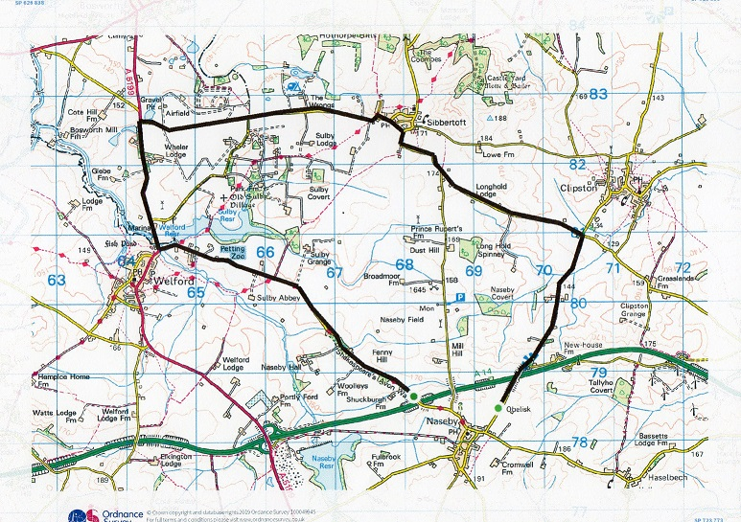

Riders MUST sign out when returning race number.

**COURSE NOTES:**

The only motor vehicles associated with the Event allowed near Start or Finish will be those of the Timekeepers

If passing any Horse Riders, please give due consideration and plenty of space. Please refrain from warming up on the course after the event has started, as this causes extra work for the timekeepers.

Please keep well into the side, while waiting to start.

You must observe the Highway Code and comply with traffic law and regulations. You must also ride in a manner that is safe for yourselves and all others, and must rely on your own ability and judgement in dealing with hazards, though every effort has been made to marshal the course and the position of ‘Event Aware’ signs, so as to minimise the risk, as required by the Course ‘Risk Assessment’. The onus is still on you the rider, so familiarise yourself with the course

**Competitors:** (A) = Association Club

|  |  |  |  |  |  |  |
| --- | --- | --- | --- | --- | --- | --- |
| Categories | S = Senior | W = Woman | J = Junior/Juvenile | | | |
| Masters Men | A=50-54 | B=55-59 | C= 60-64 | D=65-69 | E=70-74 | F=75+ |
| Masters W | A=40-44 | B=45-49 | C=50-54 | D=55-59 | E=60-64 | F=65+ |

**\*NB Masters age category is age on day of first N&DCA event ridden this year.**

**Juniors/Juveniles:** There are no separate juvenile or junior sections, only a single U19 category, i.e. Those Competitors aged under 18 or have their 18th birthday during 2024

**Result Sheet app:** Subject to availability of sufficiently tech savvy volunteers, we will be trialling the Result Sheet application which will enable you to track times live via the application on your phone if you scan the printed QR code at the Race HQ. Alternatively, you can also view the results on screen at the HQ whilst enjoying tea and home-made cakes and some lively banter.

**Season long competition prizes:** Please note that the actual value of the cash prizes awarded for performance in the various categories will be published after the last event of the season when the total prize fund is known as determined by the surplus generated by the event entry fee income. Trophies:

**Trophies:** and end of season competition prizes will be awarded at the annual Prize Award Lunch (usually held in January). NB Separate event prizes will be awarded after the last event in the series, not after each event.

The Association’s 12-hour trophies will be awarded to members of Association Clubs for their performances in any open 12-hour event held under CTT Rules & Regulations. The Association’s Long Distance BAR will be awarded to the highest placed rider of an Association Club in the National BBAR. Qualifying events are marked B in the CTT Handbook

For more information on the season long competitions and N&DCA trophies, including past winners, please refer to our website: [www.northamptondca.org.uk](http://www.northamptondca.org.uk)

**Tim Smith**

**Event Secretary**

***WVCC looks forward to welcoming you to a safe and successful event on 17th Aug***